



FUNDAMENTAL SPREADSHEET APPLICATIONS
(230)

STATE 2024

PRODUCTION
Job 1: Entering Data/Formulas __________ (150 points)
Job 2: Format Spreadsheet/Add Formulas __________ (150 points)
Job 3: Create/Format Chart __________ (75 points)

TOTAL POINTS __________ (375 points)

Test Time: 90 minutes

GENERAL GUIDELINES:
Failure to adhere to any of the following rules will result in disqualification:
- Member must hand in this test booklet and all printouts if any.
- No equipment, supplies, or materials other than those specified for this event are allowed in the testing area. No previous BPA tests and/or sample tests (handwritten, photocopied, or keyed) are allowed in the testing area.
- Electronic devices will be monitored according to ACT standards.

EXAM GUIDELINES:
- Ensure this test booklet contains Jobs 1-3.
- Key all jobs according to the instructions given.
- Correct any and all formatting, spelling or grammar errors. Use the formatting guide in the Style & Reference Manual.
- Your name or initials should not appear on any work you submit. Use your Member ID in any occasion you would normally key your reference initials.
- In the lower right hand corner of ALL work submitted (unless otherwise specified), key your Member ID and job number.
- If you complete the event before the end of the time allotted, notify the proctor. Time may be considered a factor in determining a winner when there is a tie score.
- Place your scoring sheet on top of your jobs. Jobs should be placed in numerical order.

JOB 1 (Entering Data/Formulas) | Points Possible | Points Earned
Superior Travel Agency, 14 pt. font, all caps, bold, in A1 | 5
Agent Sales Report, 14 pt. font, title case, bold, in A2 | 5
Data entered accurately (5 points per error) | 50
Insert row beneath December 2023 in Cruises section | 5
Insert TOTALS in bold in Cells A12 and A22 | 10
Sum function to total amounts of sales in Rows 12 and 22 | 10
Insert AVERAGES in bold, all caps, in cells A13 and A23 | 10
Insert function to average sales per agent in Rows 13 and 23 with no decimals | 10
No data truncated (all visible) | 5
Printout 1A: Data printed in portrait orientation | 5
Printout 1A: Member Number and Job 1A in right section of footer | 5
Printout 1B: Print Formulas (not data) | 10
Printout 1B: Landscape orientation | 5
Printout 1B: Fit to one page for printing | 5
Printout 1B: Member Number and Job 1B in right section of footer | 10
Subtotal | 150

JOB 2 (Format Spreadsheet/Add Formulas) | Points Possible | Points Earned
Numbers in Accounting format, no dollar signs, 0 decimal places | 10
Light gray, background 2, darker 10% fill in Cells A4 through G5 | 10
Data I Totals and Averages Rows bold | 5
Conditional formatting in Row 13 to highlight cells in green for any average greater than 6,000 | 10
Conditional formatting in Row 23 to highlight cells in green for any average greater than 4,000 | 10
No data truncated | 5
Member Number and Job 2A in right section of footer | 5
Job 2A printed in Portrait orientation | 5
Row inserted after Averages row with COMMISSIONS in Cell A14 and A25 | 10
Commission % typed in Cell I4 with bold format | 5
.04 in Cell I5 and .07 in I16 | 5
Number format for I5 and I16 is percentage format, 0 decimal places, bold | 10
Thick line outside border on Cells I5 and I16 | 5
Formula with absolute reference in B14 (B12x$I$5), copy across row | 10
Formula with absolute reference in B25 (B23x$I$1$6), copy across row | 10
Accounting number format with 0 decimal places, including dollar sign, and in bold, in Rows 14 and 25 | 10
Printout 2B: Fit to one page for printing, print in landscape | 10
Printout 2B: Member Number and Job 2B in right section of footer | 5
Printout 2B: Print formulas (not data) | 10
Subtotal | 150
JOB 3 (Create/Format Chart) | Points Possible | Points Earned
Create Stacked Column Chart comparing commissions earned for both Cruises and Tours for all agents | 25
Chart on a chart sheet | 10
Name chart Superior Travel Agency (line 1), and Agent Commissions (line 2) | 10
Legend labels changed to Cruises Commissions and Tours Commissions | 10
Change data fill color for Cruises Commissions to Gold, Accent 4, and for Tours Commissions to Green, Accent 6 | 10
Insert Member Number and Job 3 in right section of footer | 5
Print chart in landscape orientation | 5
Subtotal | 75
TOTAL POINTS | 375

JOB 1 – Printout 1A: Entering Data/Formulas

JOB 1 – Printout 1B: Entering Data/Formulas

SUPERIOR TRAVEL AGENCY
Agent Commission Report
 | Sales by Agent Per Month
CRUISES | Agent 1014 | Agent 1155 | Agent 1344 | Agent 1577 | Agent 1611 | Agent 1829
45108 | 10350 | 716 | 6953 | 2236 | 8343 | 4556
45139 | 7795 | 3759 | 6182 | 11912 | 5867 | 8609
45170 | 8152 | 7595 | 5395 | 4824 | 12190 | 5913
45200 | 5982 | 5642 | 2039 | 4321 | 12009 | 7306
45231 | 5547 | 6830 | 5777 | 7320 | 11769 | 4777
45261 | 3398 | 2741 | 9118 | 7017 | 9469 | 5311
TOTALS | =SUM(B6:B11) | =SUM(C6:C11) | =SUM(D6:D11) | =SUM(E6:E11) | =SUM(F6:F11) | =SUM(G6:G11)
AVERAGES | =AVERAGE(B6:B11) | =AVERAGE(C6:C11) | =AVERAGE(D6:D11) | =AVERAGE(E6:E11) | =AVERAGE(F6:F11) | =AVERAGE(G6:G11)
TOURS
45108 | 5252 | 6420 | 1445 | 1944 | 8164 | 1241
45139 | 1092 | 8996 | 6093 | 2493 | 8542 | 2400
45170 | 4839 | 5209 | 4092 | 1588 | 9643 | 2579
45200 | 4615 | 4940 | 5209 | 1536 | 7511 | 5051
45231 | 5962 | 2657 | 7620 | 3683 | 8284 | 3162
45261 | 1415 | 2736 | 1098 | 7039 | 6989 | 1944
TOTALS | =SUM(B16:B21) | =SUM(C16:C21) | =SUM(D16:D21) | =SUM(E16:E21) | =SUM(F16:F21) | =SUM(G16:G21)
AVERAGES | =AVERAGE(B16:B21) | =AVERAGE(C16:C21) | =AVERAGE(D16:D21) | =AVERAGE(E16:E21) | =AVERAGE(F16:F21) | =AVERAGE(G16:G21)

JOB 2 – Printout 2A: Format Spreadsheet/Add Formulas

JOB 2 – Printout 2B: Format Spreadsheet/Add Formulas

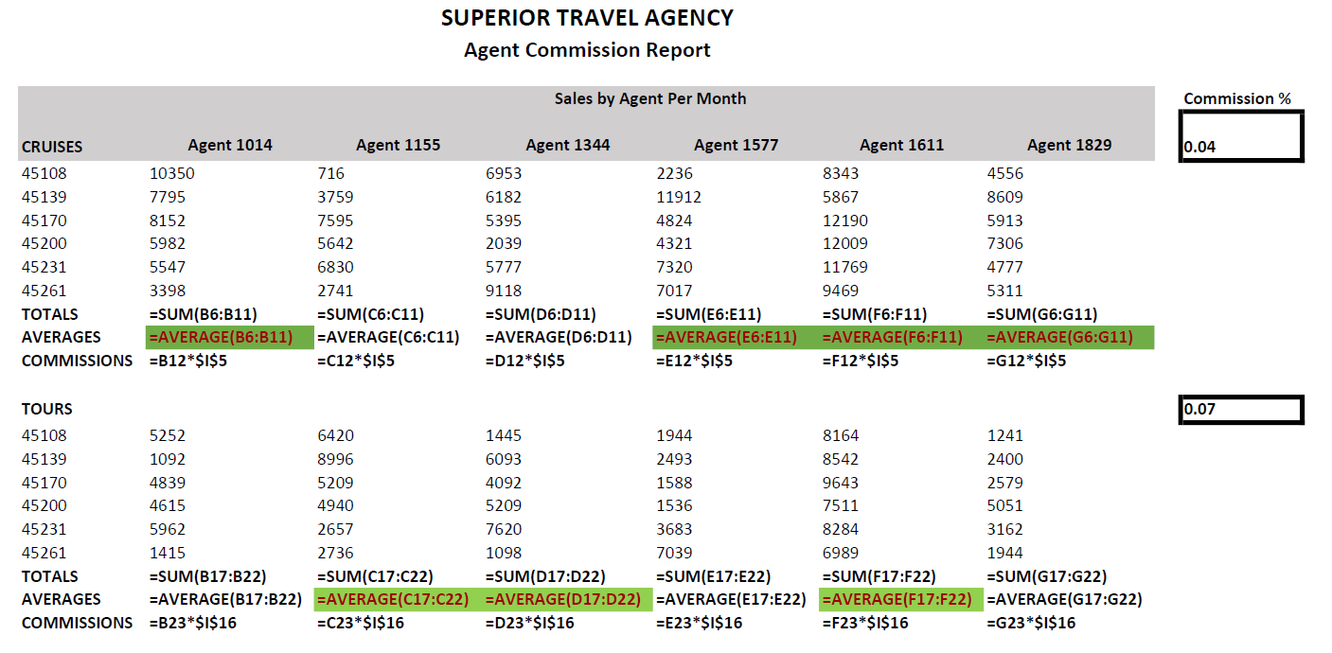

Job 3: Printout – Chart

